A000-Xian-Asclepius-Lamp with Bust-Pergamon-150 CE

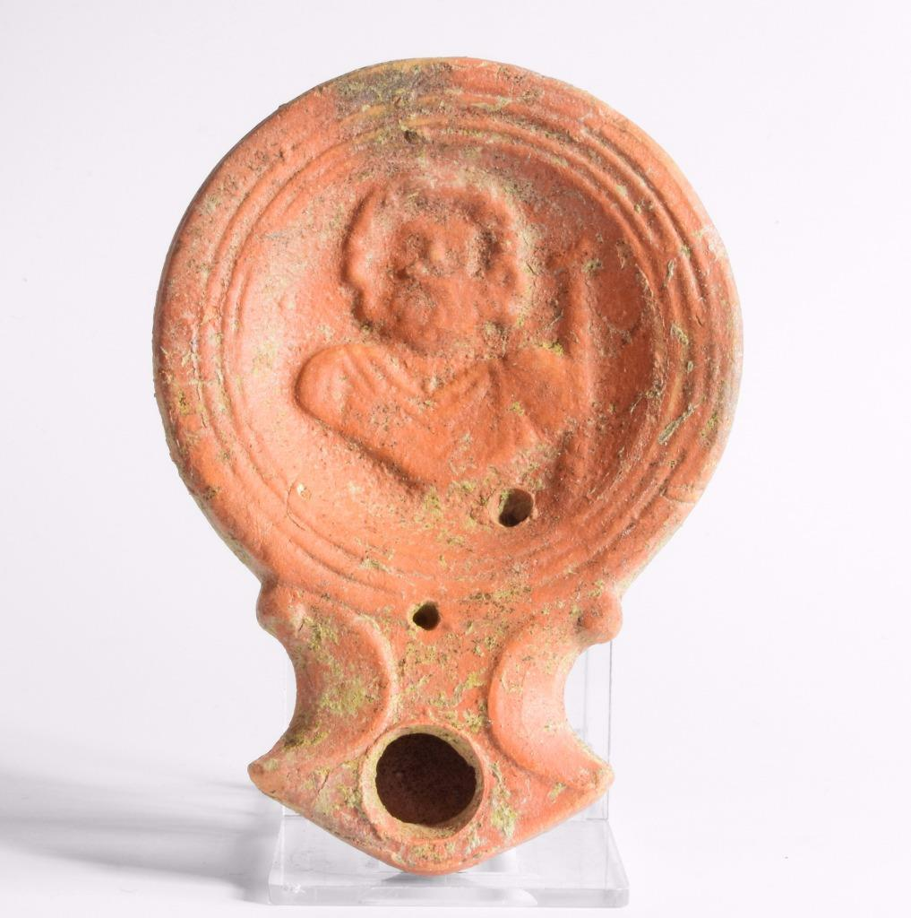

ROMAN RED CLAY OIL LAMP. AROUND FILLING HOLE ARE FAINT INCISED HOLES, CHIP ON NOZZEL WITH CARBON RESIDUE BACK TO FILLING HOLE. ENCRUSTATION AND SURFACE WEAR. 1 1/2 X 3 1/2 X 1 1/2 EX: DENVER COLLECTION **1st century Roman oil lamp with Asclepius**  
Roman red terra cotta oil lamp, 1st century CE, used in the abaton or sleeping chamber of the Asklepion at . The center of the discus decorated with the facing bust of Asclepius with his staff; small filler hole towards the volute nozzle.  
Condition: Complete and intact, with light encrustations.  
Length 9.9 cms (3.9 ins).  
**1st century AD.**

**Surgical cures under sleep induction in the Asclepieion of Epidauros**

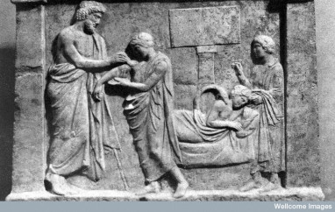

L0007389EA Relief in the form of a shrine, an offering from Archinos to Amphiaraos. First half of the 4th century BC. Credit: Wellcome Library, London. Wellcome Images.

Andrew Strathern and Pamela J. Stewart (1999; 2008, p. 67) have pointed out that **“curing – the treatment of a specific isolatable disease syndrome – can usefully be distinguished from healing – the treatment of the person and their social relations as a means of dealing with the experience of illness and its resolution in recovery or otherwise”.**

Equally, it may not even have mattered what the realities of the ‘success rate’ of each sanctuary or deity were (there were no NHS performance statistics to be collected in those days!). The mere presence of votive offerings testified to the potential healing powers of the relevant deity, intimating that these powers had intervened successfully to cure the bodies of other pilgrims. The accumulation of these objects in sacred places implied through their sheer numbers that divine treatment was a very real possibility. The iamata of the great Asclepieia of the eastern Mediterranean also spoke directly of the curative powers of the god.

Communicating with the gods through mutual exchanges and ritual was a fundamental part of maintaining the security and stability of life in the ancient world. It must have made sense for people to consider their own personal health and well-being as one of the things that the gods could choose to influence and, as a consequence, it would be similarly reasonable to connect any ill health or misfortune with an imbalance in that relationship or dissatisfaction on the part of the divine. After all, in some cases illness was thought to be divinely inspired, a form of divine punishment that might result from improper behaviour deemed offensive to the gods, including, perhaps, inattention to their needs and a lapse in the performance of certain acts of worship. As Meredith McGuire (1990, p. 285) has observed, “since our important social relationships, our very sense of who we are, are intimately connected with our bodies and their routine functioning, being ill is disruptive and disordering.” The act of making a prayer, a vow or an offering, of seeking to ensure that the relationship between yourself and the divine was as it should be and that ‘all was well with the world’ may have been key to ensuring that ‘all was well’ with your body, even if you continued to experience pain or other symptoms. Offering a votive might, in other words, address the holistic experience and expectations surrounding illness and its causes, as much as it was ever expected to make it go away completely.

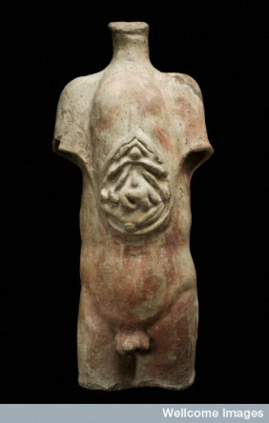

A votive torso: opening up the whole person to the intervention of the gods? L0058445 Roman, 200 BCE-200 CE Credit: Science Museum, London. Wellcome Images

As Strathern and Stewart (2008, p. 67) note, ‘curing, narrowly conceived, may be said to separate mind and body, whereas healing can be said to unite them.’ Anatomical votives by their very nature compel us to focus on the body and its constituent parts, but maybe some were intended to refer to a more general sense of physical health and well-being, an opening up or sharing of the body and its essence with the divine. As a consequence we might consider re-examining the emphasis that we place on the choice of body parts dedicated and the role of these material objects as direct signifiers of a person’s state of health.

Perhaps too we could think about revising prevailing ideas about how ancient people conceived of illness, impairment and health. I suspect that in many instances the lines that we as scholars can draw so easily between categories of ‘healing’ and ‘curing’ were blurred and it may be inappropriate to try to apply these labels too strictly. Nevertheless, for me at least, they have made me think more critically about exactly what anatomical votive offerings associated with health aimed to do and what the expected outcomes were. In many cases, the sense of well-being resulting from communicating directly with the divine realm, sharing that experience in a communal setting with other pilgrims and petitioners and knowing that others have done the same before you perhaps resulted in a sort of healing of a person’s sense of self and bodily security which meant that even if no direct cure was forthcoming votive cult really could be said to have ‘worked’ to restore unbalanced bodies.

E-J Graham

**References**

Graham, E-J. Forthcoming. Mobility impairment in the sanctuaries of early Roman Italy. In C. Laes (ed.). Disabilities in Antiquity. London and New York, Routledge.

McGuire, M.B. 1990. Religion and the body: rematerializing the human body in the social sciences of religion. Journal for the Scientific Study of Religion 29(3), pp. 283-96.

Strathern, A. and Stewart, P.J. 1999. Curing and healing: medical anthropology in global perspective. Carolina Academic Press.

Strathern, A. and Stewart, P.J. 2008. Embodiment theory in performance and performativity. Journal of Ritual Studies 22(1), pp. 67-71.

Provenance: This item is not a UK find and as such is not subject to the Portable Antiquities Scheme. Purchased from a prominent London dealer and previously acquired legally on the UK Arts market in the 1990's.  
Supplied with illustrated COA



[Hubert Robert](https://www.art.com/gallery/id--a641/hubert-robert-posters.htm), Small Temple of Asclepius, Villa Borghese, Rome, Late 18th Century/

**Hubert Robert** (22 May 1733 – 15 April 1808) was a French [painter](https://en.wikipedia.org/wiki/Painting), noted for his landscape paintings and [capriccio](https://en.wikipedia.org/wiki/Capriccio_(art)), or semi-fictitious picturesque depictions of ruins in Italy and of France.[[](https://en.wikipedia.org/wiki/Hubert_Robert#cite_note-re-1)